Preface

This User Guide explains how to use the system to process multi-currency and multi-applicant guarantees. It assumes that you are familiar with the basic principles of trade finance relating to guarantees together with web browsers.

# Introduction

## Overview

This document describes the functionality introduced for multi-applicant and multi-currency guarantees as part of Fusion Trade Innovation.

This allows the bank to:

* Issue a guarantee in:
* multiple currencies for a single applicant
* a single currency with multiple applicants
* multiple currencies with one or more applicants for each currency.
* Link an applicant guarantee to a participation deal.
* Enter a counter guarantee amount for the transaction as a whole or against each individual guarantee amount.
* Generate the following release items for each sub-guarantee amount
* charges
* documents and SWIFT messages
* postings.
* Request limit checking and facility processing for each applicant and their associated guarantee amounts.
* Process the individual guarantee amount details independently throughout the life of the transaction in terms of amendment/ad, cancellation, payment and expiry.
* Extend sub-guarantees to have additional data elements through static data maintenance.

## Scope

The following items are **not** available under multi-applicant/currency guarantees

* The ability to submit the multiple elements of a multi-applicant/multi-currency guarantees from an external system via Gateway in terms of issuance, take-on or data exchange. Details can however be passed as additional data items within the messages and mapped manually.
* Financing of payment amounts under Claim received.
* Renewals and reductions for multiple applicant/multiple currency guarantee amount.
* Customer share and bank share liability parties via customer/bank share postings as liability amounts can be booked for an applicant’s guarantee amount.

# Multi-Applicant and Multi-Currency Guarantees

## Multi-Applicant/Multi-Currency Features

When entering a guarantee for a single applicant and single currency the system processing is unchanged.

The left-hand menu allows the user to select a multi-applicant/multi-currency transaction input screen

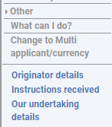

Once selected, the following settings are available to allow the user to specify that they are entering a multi-applicant and/or multi-currency guarantee.

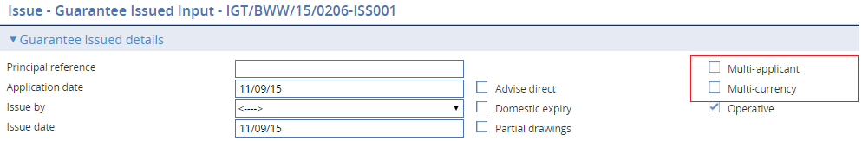

The following ‘attachment types’ allow charges, documents and posting rules to be generated for the following items related to the sub-guarantees:

* Guarantee currency – overall guarantee currency amount
* Applicant guarantee – applicant and their associated amount details
* Reimbursing party – where there are multiple reimbursement currencies

## Guarantee Issued – Single Applicant - Multi Currency

The guarantee issued event allows multiple amounts to be entered for a Single applicant (with or without counter guarantees). For example,

Applicant ABC request their bank to issue a guarantee for 20m USD and 50M EUR.



* The guarantee type Tender, Performance etc. applies to all amounts.
* The basic overall terms of the guarantee apply to all guarantee amounts – in the example the bank is issuing the guarantee and requesting THFT bank to advise the guarantee to the beneficiary Delaware Power Company.
* The guarantee amount is for 20m USD and 50m EUR.
* A different expiry date can be entered for each currency.
* A counter guarantee can be entered for either or both amounts.

When **Multi-currency** is selected:

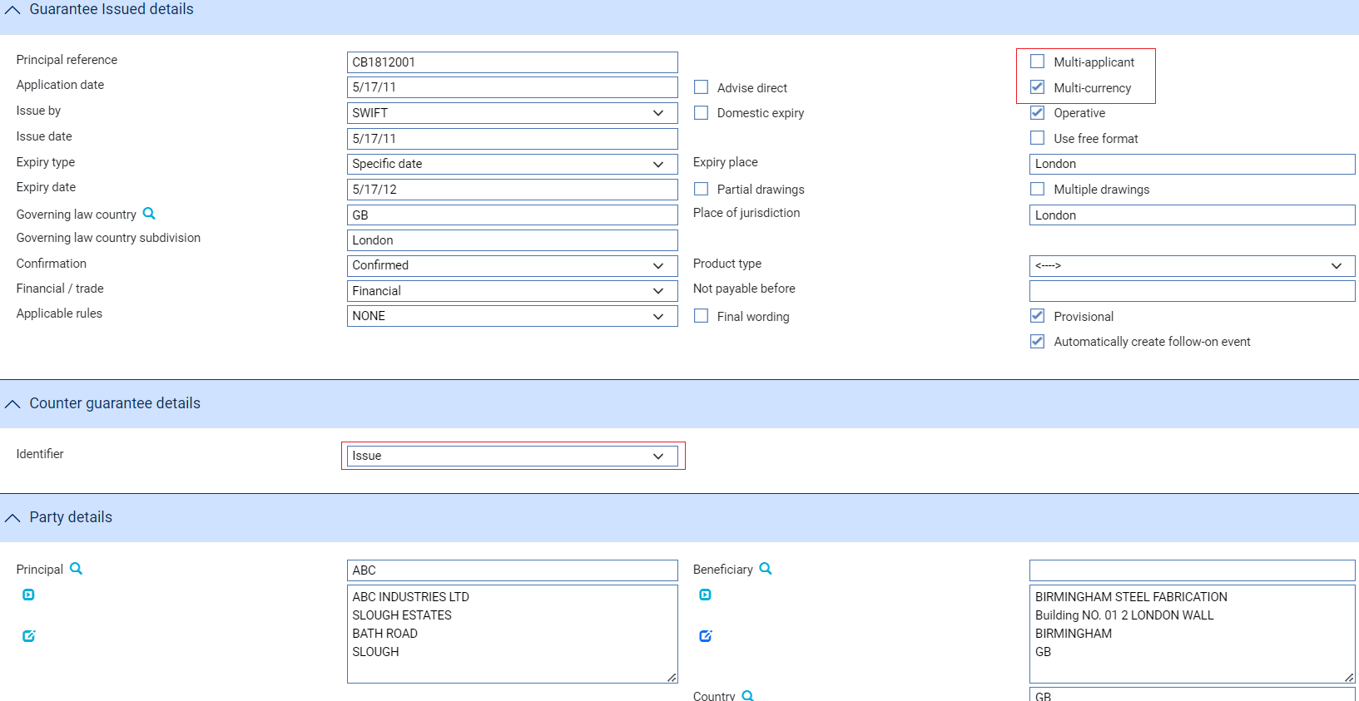

The guarantee identifier allows the bank to

* ‘Issue’ the guarantee - requesting the advising bank to advise the guarantee
* ‘Request Issue’ – requesting the issuing bank to issue their own guarantee (with the bank sending details of their own counter guarantee)
* ‘Counter received - Issue’ – this is used where a counter has been received and the bank is requesting the advising bank to advise the bank’s own guarantee
* ‘Counter received - Request Issue’ – this is used where a counter has been received and the bank is requesting the issuing bank to issue their own guarantee based on the bank sending details of their counter guarantee

The **Amount details** section allows the details of each of the guarantee amounts to be entered.

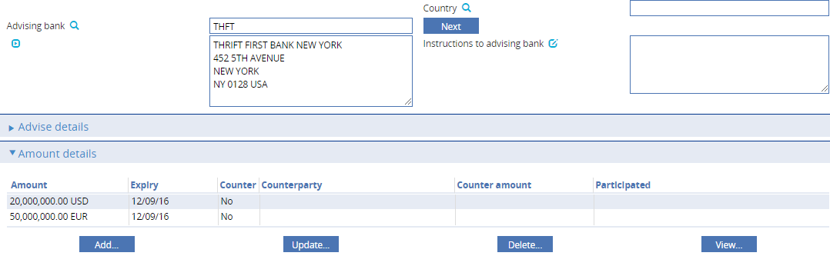

When **Add...** is selected, the details of each individual guarantee amount can be entered as follows:

* Party
* Amount
* Counter guarantee amount
* Participation details
* Charge details
* Margin details

Applicant party details

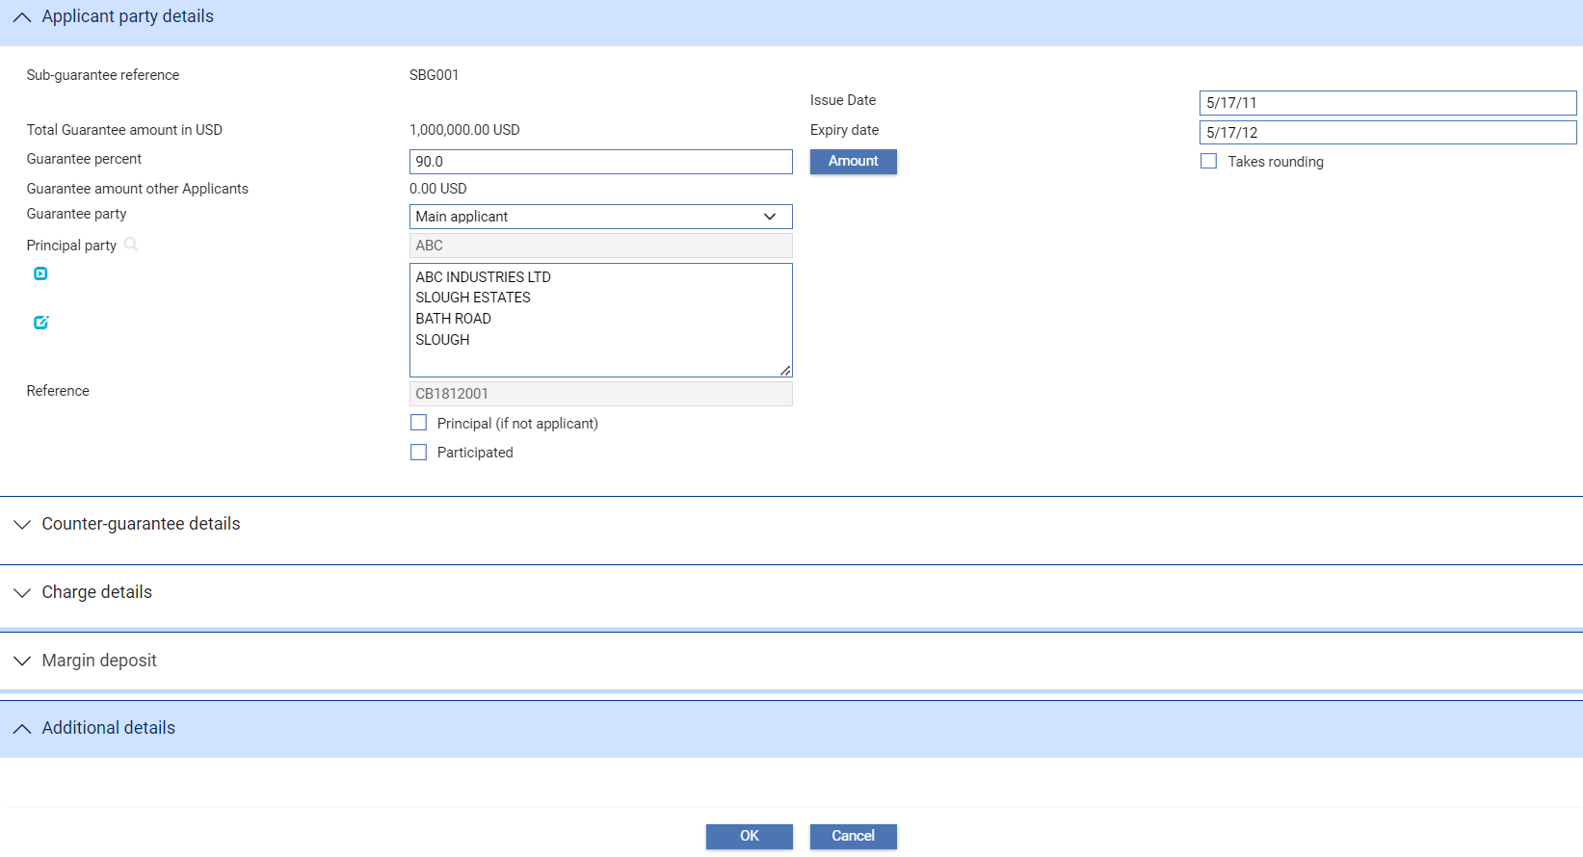

|  |  |
| --- | --- |
| Field | What to Enter |
| Guarantee amount | Applicant guarantee amount for the applicant |
| Expiry date | Date guarantee amount expires |
| Is main Applicant | Identifies this party as the main applicant |
| Principal party | Party to which guarantee amount relates |
| Principal (if not applicant) | Allows details of an additional party against which liability may be recorded such as a head office |

Counter guarantee amount

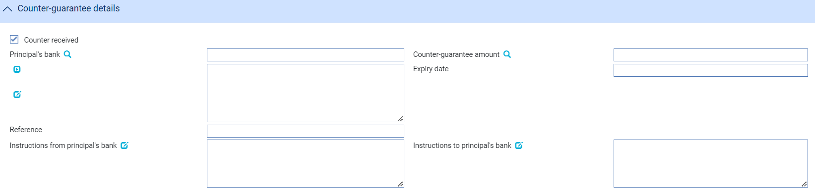

|  |  |
| --- | --- |
| Field | What to Enter |
| Counter guarantee | Selected where a counter guarantee amount is required |
| Counter guarantee amount | Counter guarantee amount – can be in a different currency to the applicant guarantee amount |
| Expiry date | Date guarantee amount expires |
| Is main Applicant | Identifies this party as the main applicant |
| Principal’s bank | Bank providing the counter guarantee |
| Instructions from Principal’s bank | Allows details of any instructions from the principal’s bank |
| Instructions to Principal’s bank | Allows details of any instructions for the principal’s bank |

Charge details for the Applicant

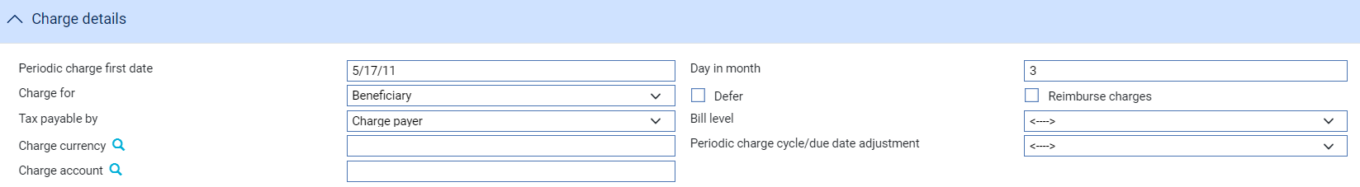

|  |  |
| --- | --- |
| Field | What to Enter |
| Periodic charge start date | Next periodic charge date |
| Day in month | Counter guarantee amount – can be in a different currency to the applicant guarantee amount |
| Charge for | Applicant or Beneficiary |
|  |  |
| Defer | Whether charges are to be deferred |
| Reimburse charges | If charges are to be reimbursed |
| Tax payable by | Either Charge payer, Applicant or Beneficiary |
| Charge currency | Preferred charge currency |
| Charge account | Account from which charges will be debited |

Margin details

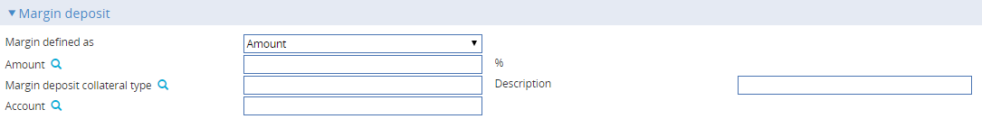

|  |  |
| --- | --- |
| Field | What to Enter |
| Margin defined as | Amount or percent of guarantee amount |
| Amount or Percent | Specific amount or Percentage of the guarantee amount |
| Margin deposit collateral type | Applicant or Beneficiary |
| Description | Whether charges are to be deferred |
| Account | Settlement account from which margin is to be debited |

Reimbursing instructions

Where reimbursing instructions are to be entered, each currency is shown in the Reimbursing details table.

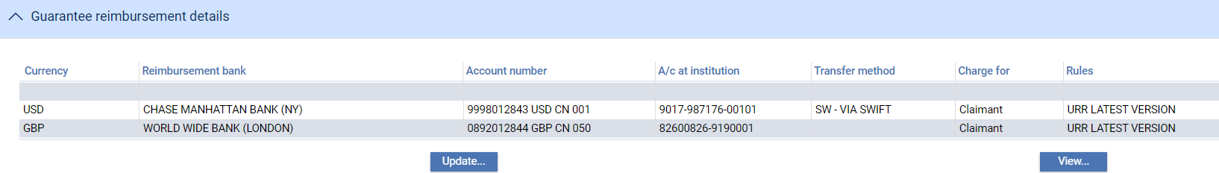

Select a row in the Guarantee reimbursement details pane and click Update... Details can be entered as follows:

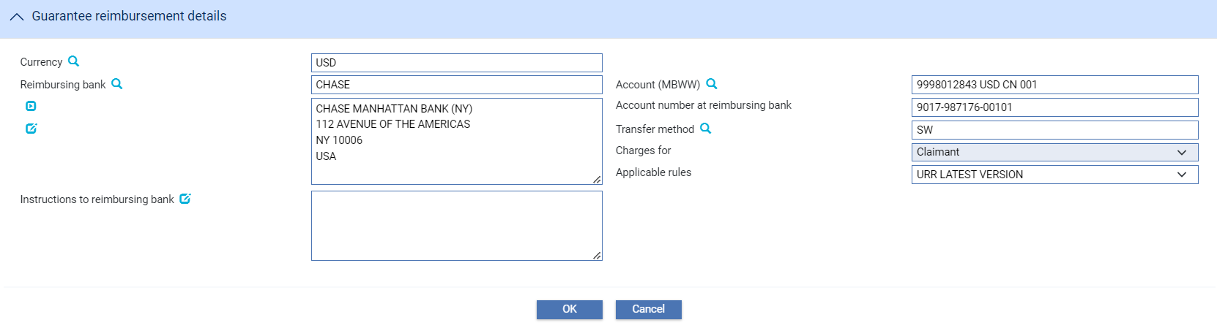

|  |  |
| --- | --- |
| Field | What to Enter |
| Currency | Currency of the reimbursement |
| Reimbursing bank | Reimbursing bank |
| Account | Account number in our books |
| Account number at reimbursing bank | Corresponding account to be debited at the reimbursing bank |
| Transfer method | Method by which to send reimbursing instructions |
| Charges for | Charges paid by either Issuing bank or Claimant |
| Applicable rules | NOTURR or URR LATEST VERSION |
| Instructions to reimbursing bank | Instructions for the reimbursing bank |

## Multi-Applicant – Single Currency

The guarantee issued event allows multiple applicants to be associated with a single currency (with or without counter guarantees) e.g.

* Applicant ABC requests the bank to issue a guarantee for 100m USD and split between two applicants 60% and 40%.

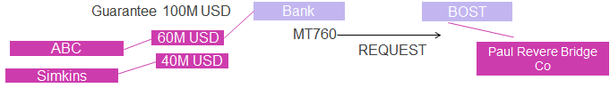

* The guarantee type Tender, Performance etc. applies to all amounts
* The basic overall terms of the guarantee apply to all guarantee amounts – in the example the bank issues the guarantee and requesting BOST bank to issue the guarantee to the beneficiary Paul Revere Bridge Construction
* The guarantee amount is for 100m USD split 60% and 40%
* A different expiry date can be entered for each party where required

When Multi-applicant is selected, the user can enter details of each applicant’s share as follows:

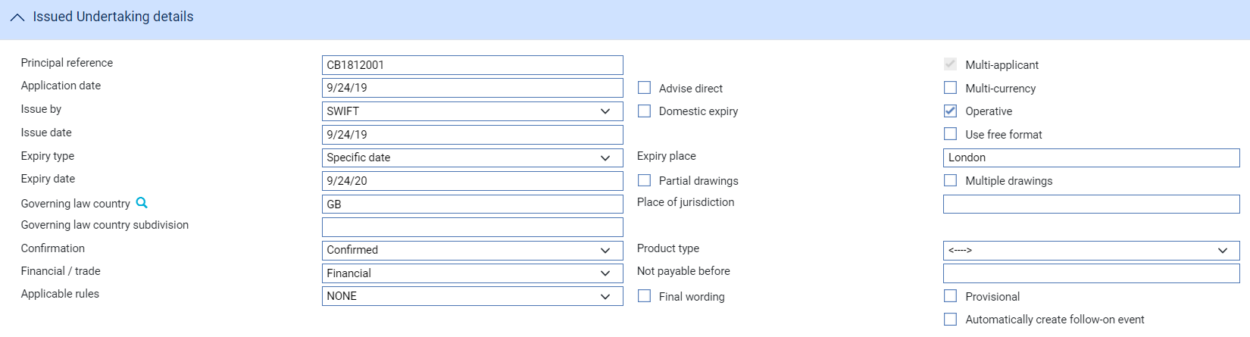

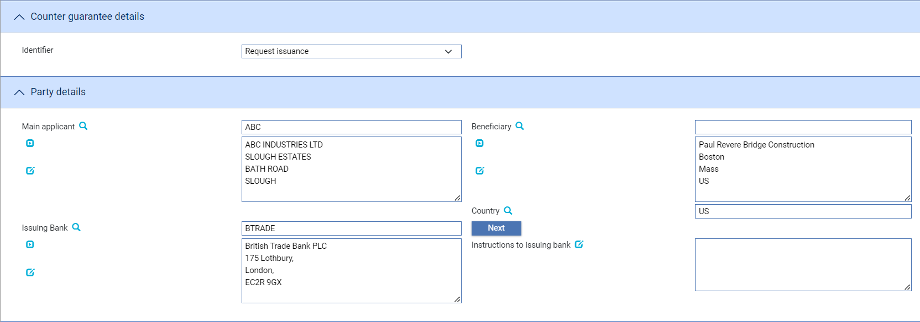

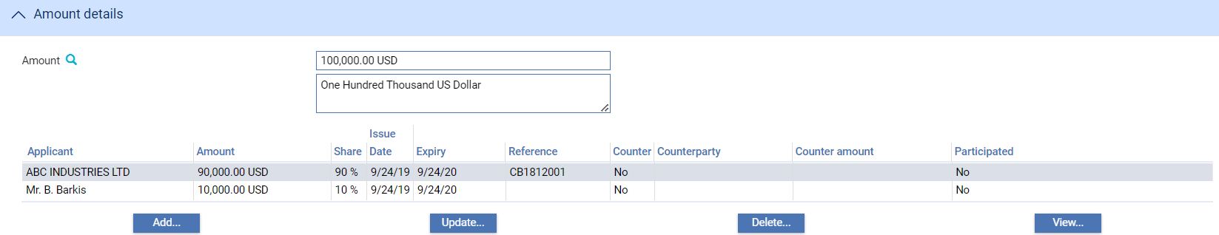

When **Add...** is selected, the user can enter details of the applicant and their share as described above together with any charge and margin details plus details of any counter guarantee (where the request is from another bank)

## Multi-Currency – Multi-Applicant

The guarantee issued event allows multiple applicants to be associated with multiple currencies (with or without counter guarantees). For example,

The Applicant - World Industries requests the bank to issue a guarantee for

* 20m GBP split between two applicants SOUTH (75%) and NTHWST OIL (25%)
* 10M EUR split between EASTRN (60%) and WESTRN OIL (40%)

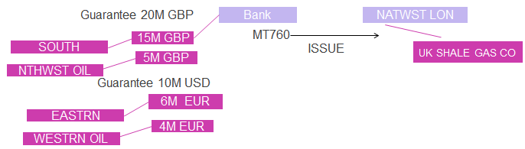

* The guarantee type Tender, Performance etc. applies to all amounts.
* The basic overall terms of the guarantee apply to all guarantee amounts – in the example the bank is issuing the guarantee and requesting NATWEST LON bank to advise the guarantee to the beneficiary UK SHALE GAS CO company.
* A different expiry date can be entered for each currency as required

When Multi-applicant and Multicurrency are both selected, the user can enter details of each applicant’ share as follows:

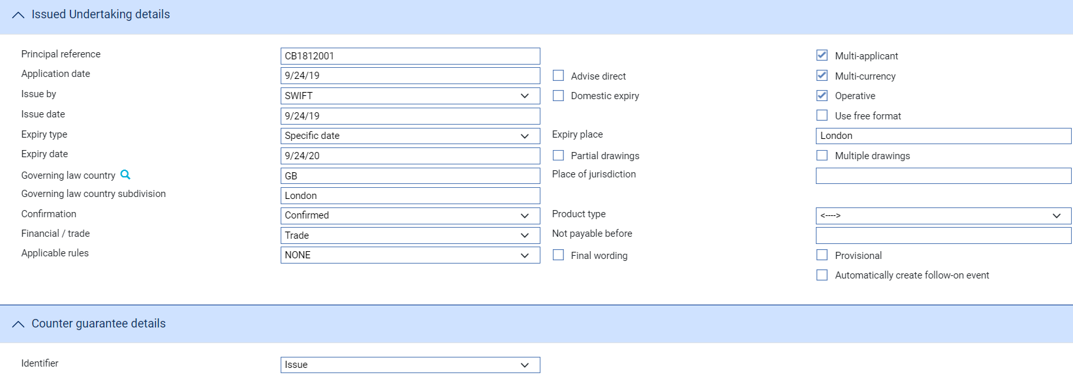

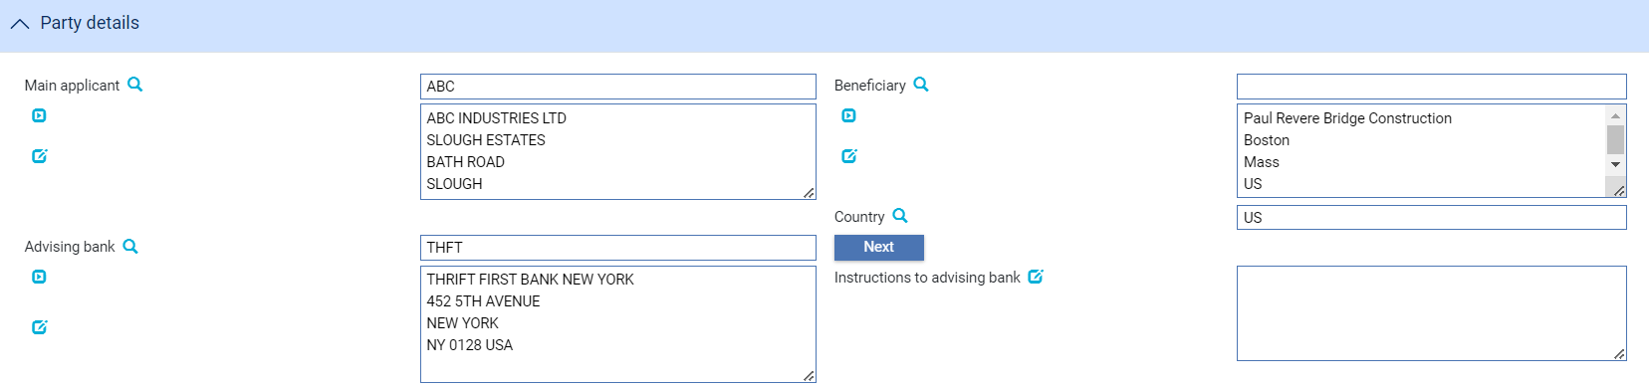

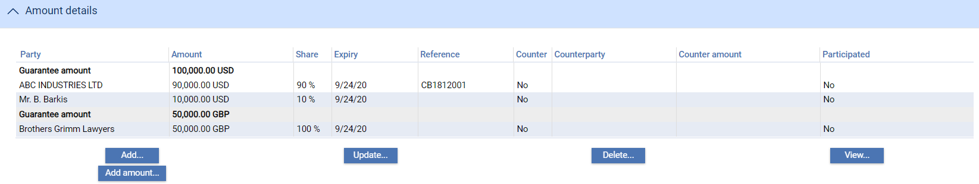

## Counter Guarantee

Where another bank requests the receiving bank of the MT760 to issue their own guarantee, there are two options available in the Guarantee issue event to condition further processing

* **Counter received - Issue** – In this case, the receiving bank issues a guarantee based on the counter they themselves have received and will issue their own guarantee to the advising bank (or directly to the beneficiary) recording liability against the bank from whom they received instructions.
* **Counter received- Request issue** – In this case, the bank will request further bank to issue their own guarantee based on their counter guarantee (they themselves having also received a counter guarantee).

Depending on the details of the counter guarantee, e.g. whether the counter guarantee is for a single amount, covers multiple currencies or covers counter guarantees from different banks; the bank may either

* record the full amount against the transaction or
* apportion the counter guarantee amount against each different applicant guarantee amount or
* enter specific currency amounts against each sub guarantee with the relevant counter bank.

## Participations/Export Credit Agency Facility

A sub-guarantee amount entered for a specific applicant can be linked to a participation or facility using standard common features.

This allows the sub guarantee amount to be linked to a new or existing Participation deal or Facility to share risk with other banks.

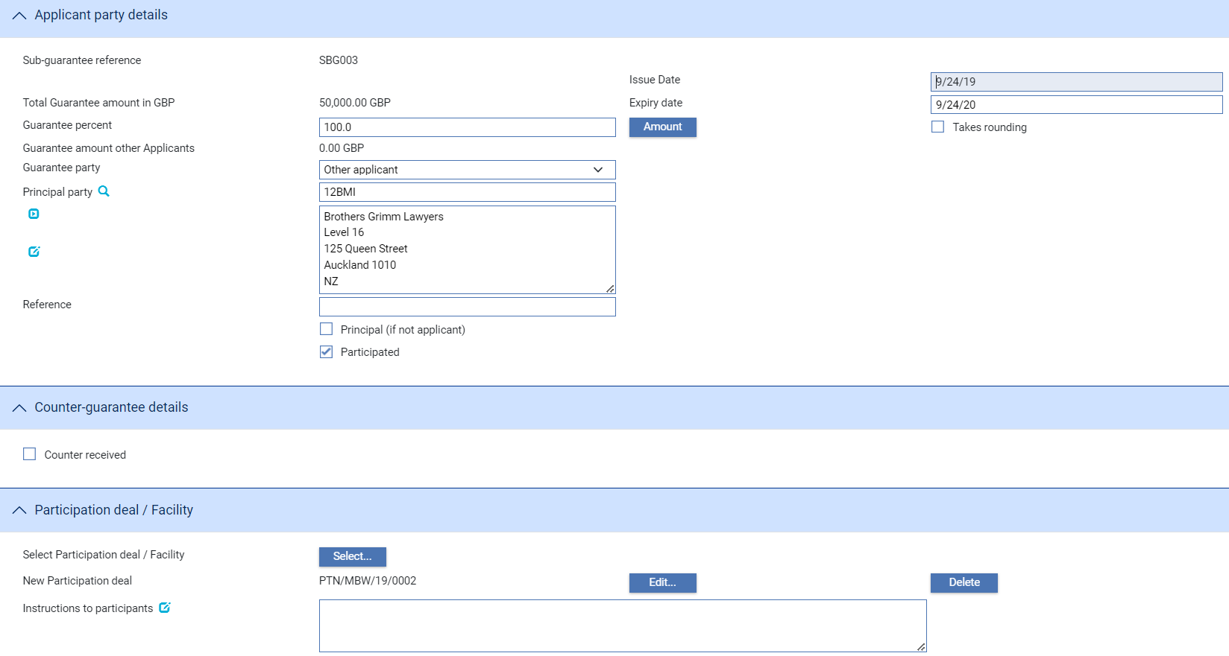

The participation is then recorded against the sub-guarantee amount.

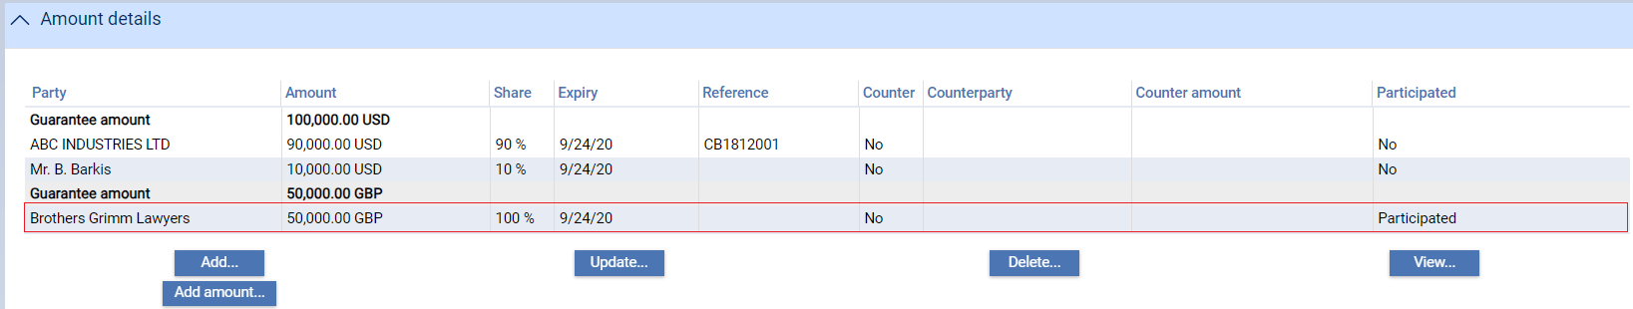

## System Tailoring Features and Release Items

The following ’attachment’ types, event fields and event field tables allow the bank to generate the required release items. The key attachments used are

* Guarantee applicant – this attachment type allows:
* Charges to be associated with each individual guarantee amount for an applicant such as periodic charges. The attachment type makes the relevant amount and start and end dates available for charge calculations
* Clauses
* Documents and SWIFT messages to be produced to each applicant amount
* Liability postings to be generated for each applicant
* Limit checking to be performed separately for each applicant
* Reimbursement party – this attachment type allows:
* Reimbursement instructions to be sent to each for each currency involved in the guarantee
* Sub-guarantee amount total – this attachment type allows:
* Charges to be associated with overall guarantee totals
* Clauses

Event level event field tables contain information related to:

* Guarantee applicant details
* Guarantee reimbursement details
* Sub-guarantee amount details

1. To assist in System Tailoring, the special event field ‘Single-applicant/Single currency guarantee’ can be used to simplify the rules definition used to determine the release items to be generated.

## Common Events

The existing common events such as Tracers, Correspondence, Manual Bookkeeping, Maintain charges, Pay periodic charges and Maintain share liability are available as part of a multi-applicant/Multi-currency guarantee processing.

## Additional Notes on General Input Fields

Where a guarantee is multi-applicant and/or multi-currency is being entered, the following input fields are either

* made available at the sub-guarantee level rather than at transaction level
* have different values/options
* are not applicable when compared to a single applicant single currency guarantee

|  |  |
| --- | --- |
| Field | Processing under multi-applicant/currency |
| Customer counter guarantee and expiry date | Not applicable |
| Standby flag | Not applicable |
| Additional amount fields | Not applicable |
| Margin deposit | Details are defined at the guarantee amount level |
| Charge details | Charge details are defined at guarantee amount level except for Overseas charges for and Charge text which are entered at transaction level |
| Reduction/Increase details | Not applicable |
| Renewal/Rolling renewal details | Not applicable |
| Customer share and bank share liability via customer/bank share party postings | Liability amounts can be booked for parties against the individual guarantee amounts |
| Charge details | Details of the applicant are displayed in the charge window instead of Buyer/Seller text |

## Guarantee Master Summary and Details Screen

The Master summary screen shows details of the sub guarantee amounts and parties as follows:

Example – Single-applicant Multi-currency

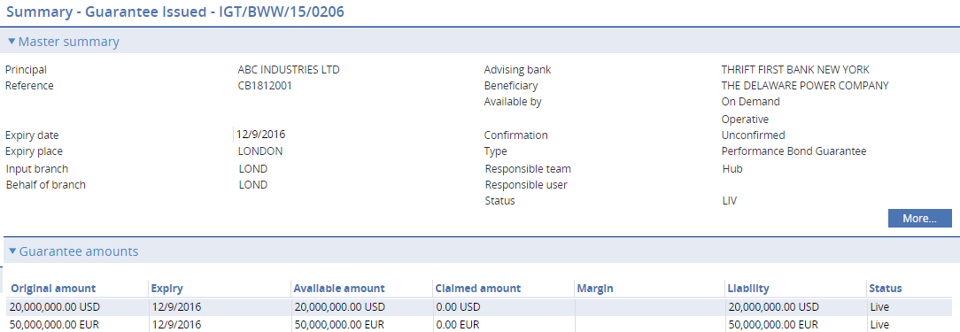

Example – Single currency –Multi-applicant

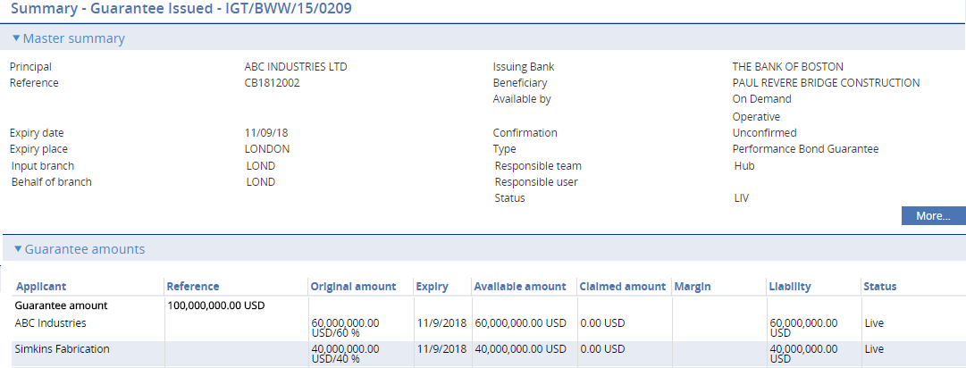

Example - Multi-applicant - Multi-currency

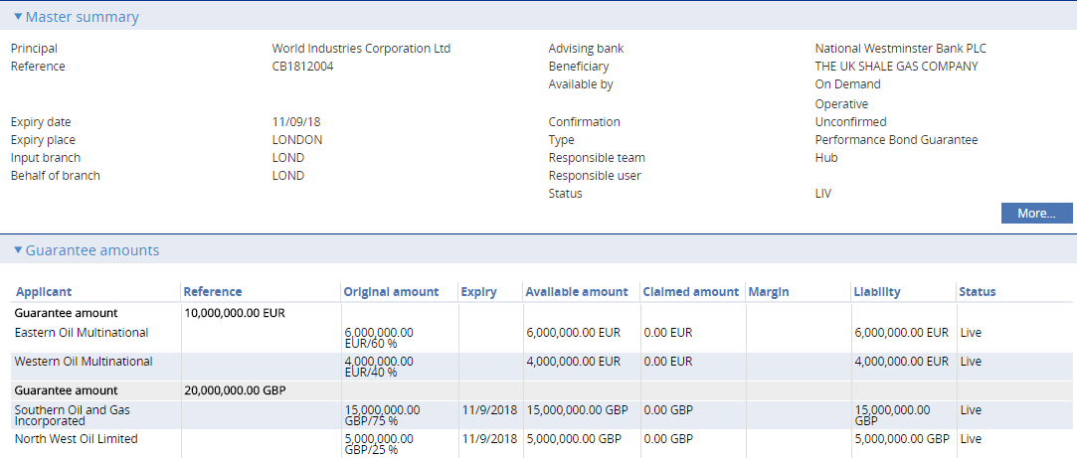

## Guarantee Issued Amend/Adjustment

Once issued, a guarantee can be amended or adjusted (with or without requiring beneficiary approval) as required to

* change amounts against existing applicants
* parties – add additional parties
* change, dates and terms and conditions

The same input functions used to add the details as part of issuing the guarantee are also used when maintaining the guarantee.

The View event changes from the left-hand menu allows the user to view ***basic*** details of the amendments.

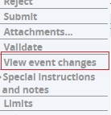

In the following example, the overall expiry date has been changed and sub-guarantee amounts have been amended.

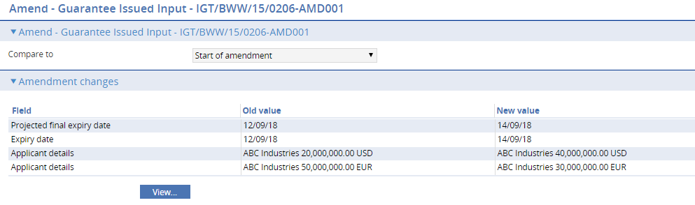

## Guarantee Issued - Cancellation

When a multi-applicant/multicurrency guarantee is selected for cancellation, the overall guarantee details are displayed and the user is able to enter following details: -

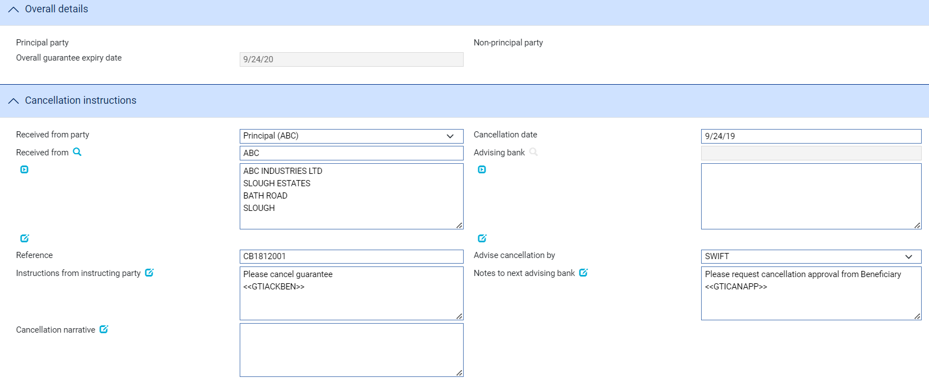

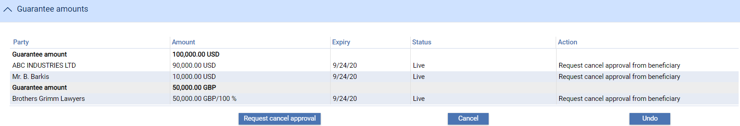

|  |  |
| --- | --- |
| Field | What to Enter |
| Received from party | The party requesting the cancellation. This can be either the main applicant, a specific applicant or counter guarantee bank |
| Cancellation date | The date the cancellation is to take effect |
| Instructions received for the applicant | Any specific instructions regarding the cancellation |
| Cancellation narrative | Cancellation narrative regarding the cancellation |
| Instructions to advising/issuing bank | Instructions to bank that was requested to advise or requested to issue the guarantee |

The user is able to:

* **Cancel** one or more individual guarantee amount or
* **Request cancel approval** from the beneficiary for one or more guarantee amounts
* **Undo** to reset the status

## Guarantee Issued - Beneficiary Response to Cancel

When a beneficiary response to cancel request is received, the following details are displayed allowing the user to record the Cancellation request response

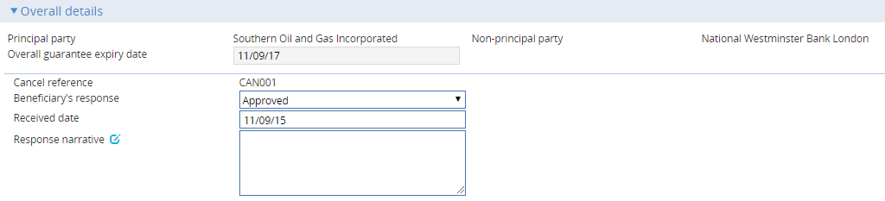

This allows the user to record

* The beneficiary’s response – Approved or Rejection. This automatically sets the Approve/Reject status against the previous requests requiring approval
* Details of the Beneficiary’s response

The user can review the original cancellation details and select Approve or Reject to update the previous outstanding request manually.

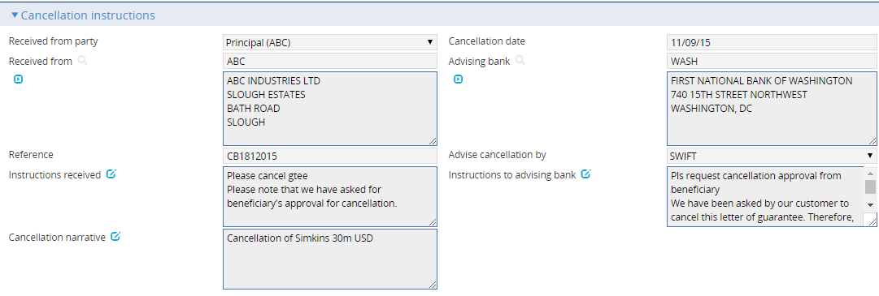

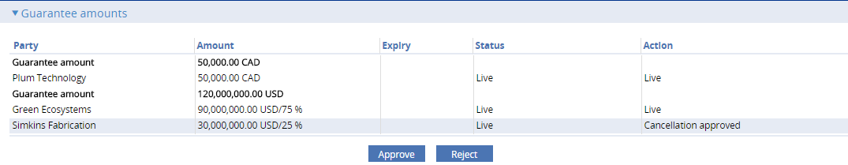

If the Cancellation is approved, the status of the sub-guarantee is set to Cancelled against the master.

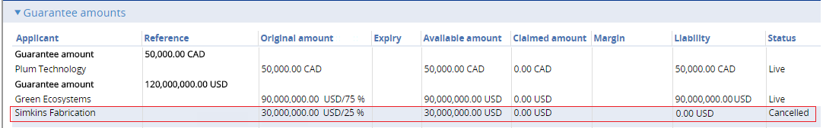

## Claim Received and Outstanding Claim

Where a claim is made against a multi-applicant/currency, the following details are displayed allowing details of the claim to be recorded.

The presenter’s actions are definable by the bank and can be extended to include actions such as ‘Pay or extend request’.

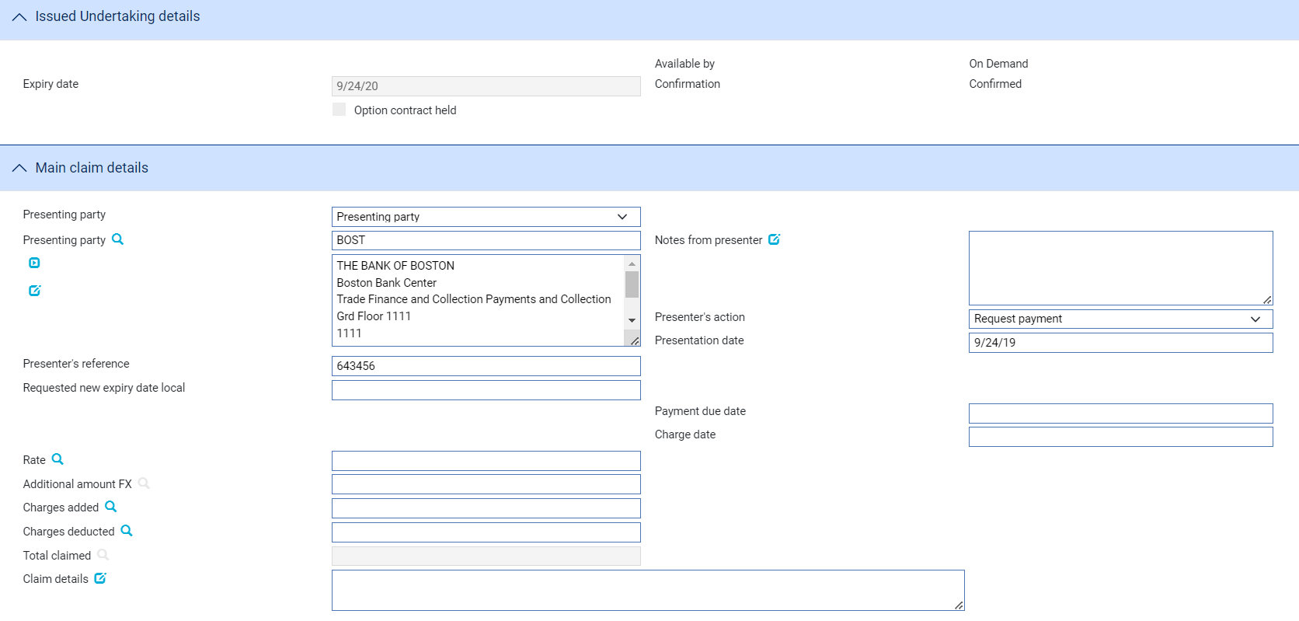

The payment option allows the user to select a bank defined payment option (these are configurable in system tailoring) such as

* Pay
* Reject
* Request approval from applicant

Where there is a **single amount** to be paid under a single applicant/multi-currency guarantee, the following details are shown in the event:

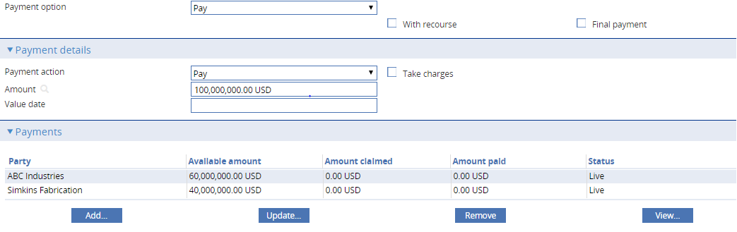

Where there are **multiple guarantee amounts**, the payment details table is initially shown empty allowing the user to select required guarantee amount for payment.

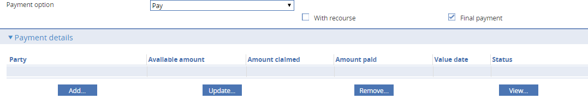

When **Add...** is selected the, user can select the guarantee amount that is to be paid from the list of amounts available.

Example 1 – Multicurrency – multi-applicant

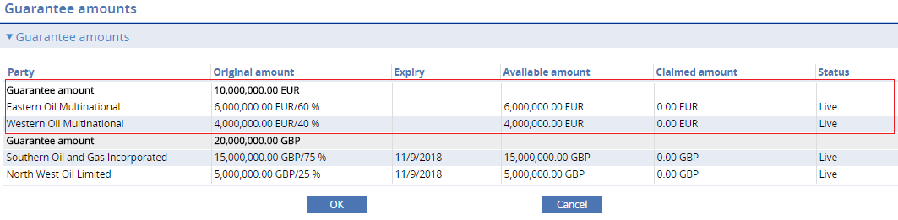

Example 2 – Multicurrency – single applicant

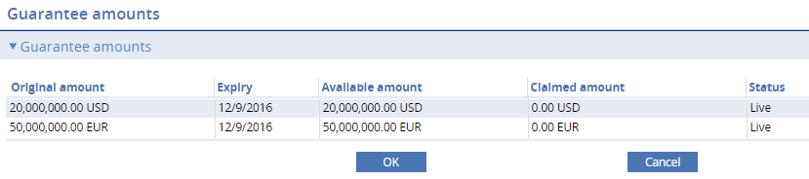

When a guarantee amount is selected form the browser, the guarantee details and associated applicants are shown in the main event window.

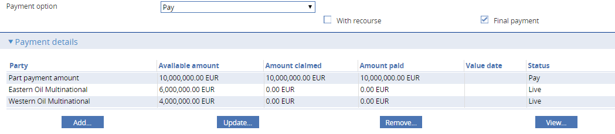

The user can Update... the relevant *Part payment amount* line item to enter the

* Payment action required e.g. Pay or pay at maturity
* Payment amount
* Take charges flag – if charges are to be associated with this payment
* Value date of the payment

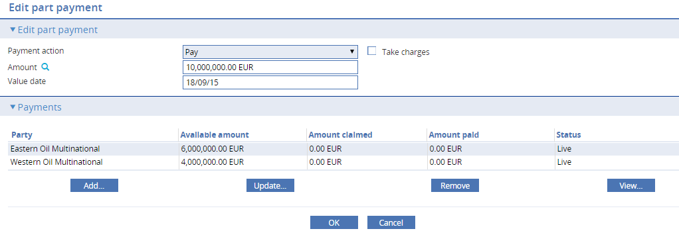

The details of the individual applicant paying the guarantee can be updated from either the Edit part payment window or from the main event window.

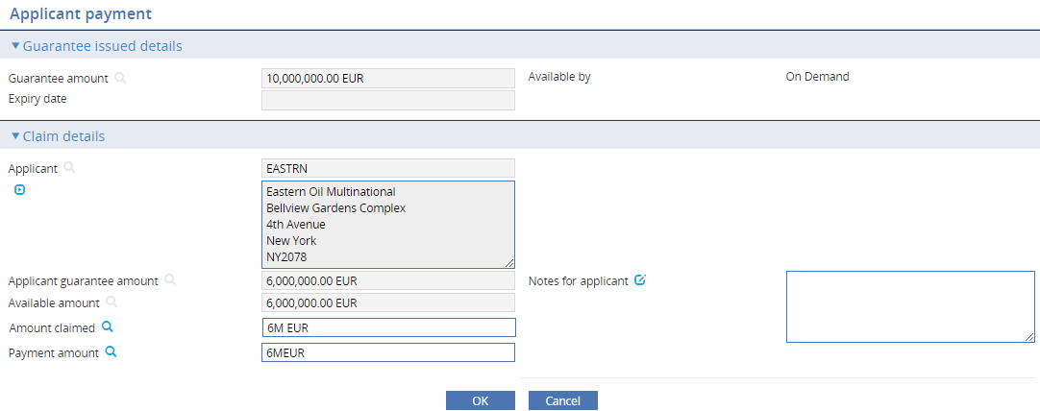

The following details can be entered:

* Amount claimed
* Payment amount
* Notes for applicant

Reimbursement details

The guarantee reimbursement details screen allows the user to cancel the reimbursement authority if no further claims are to be processed.

The reimbursement details are displayed as follows

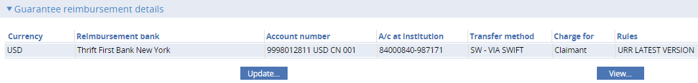

The **Update...** button allows the following details to be amended.

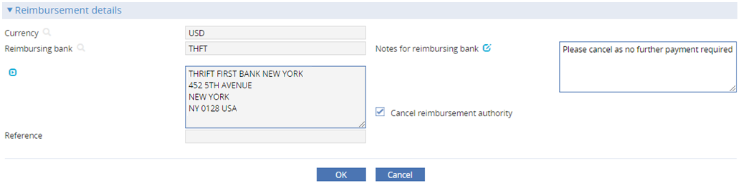

Where the claim requires further approval from the applicant or is to be paid at a future date, the claim can be continued by an Outstanding Claim event.

Once paid, the guarantee amount is set to paid in the Master summary.

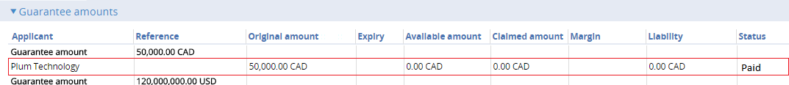

## Guarantee Issued - Expiry

Where an Expire event is created against a multi-applicant/multi-currency guarantee, the following screen is displayed.

Example 1 – Multicurrency/Multi-applicant or Multi-applicant

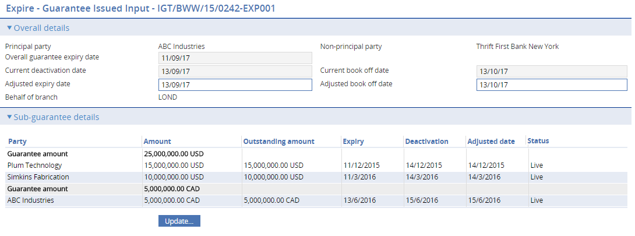

Example 2 - Multi-currency

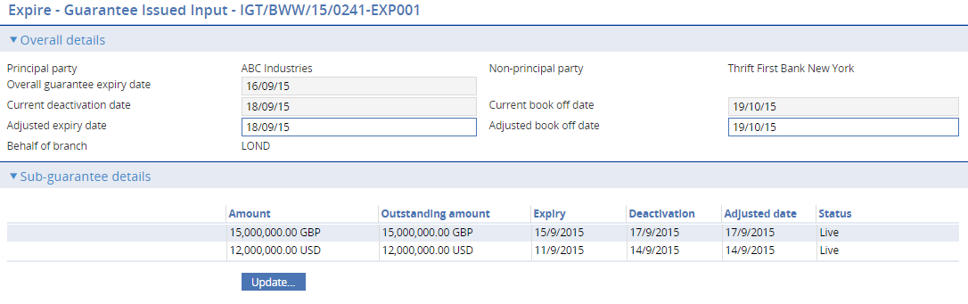

The initial overall details provide information on the overall expiry of the guarantee together with the adjusted expiry date and book off date.

The individual sub-guarantee details show the guarantee amounts and their individual expiry dates.

When **Update...** is selected the details of an individual guarantee amount can be amended as follows.

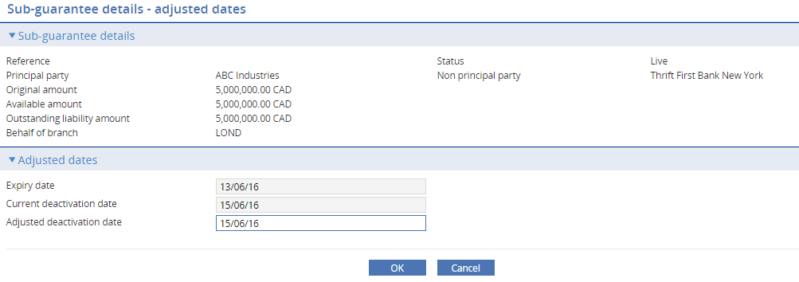

As each guarantee is expired and the status of the guarantee is set to **Expired,** a new diary event is automatically scheduled in the Diary items against the master for the next earliest expiring sub-guarantee date.

## Guarantee Issued - Book off

Once all sub-guarantee amounts are expired, the book off event flags the master as BKF - Booked off.

